EduGenie
Generative AI Learning Assistant
Project Documentation
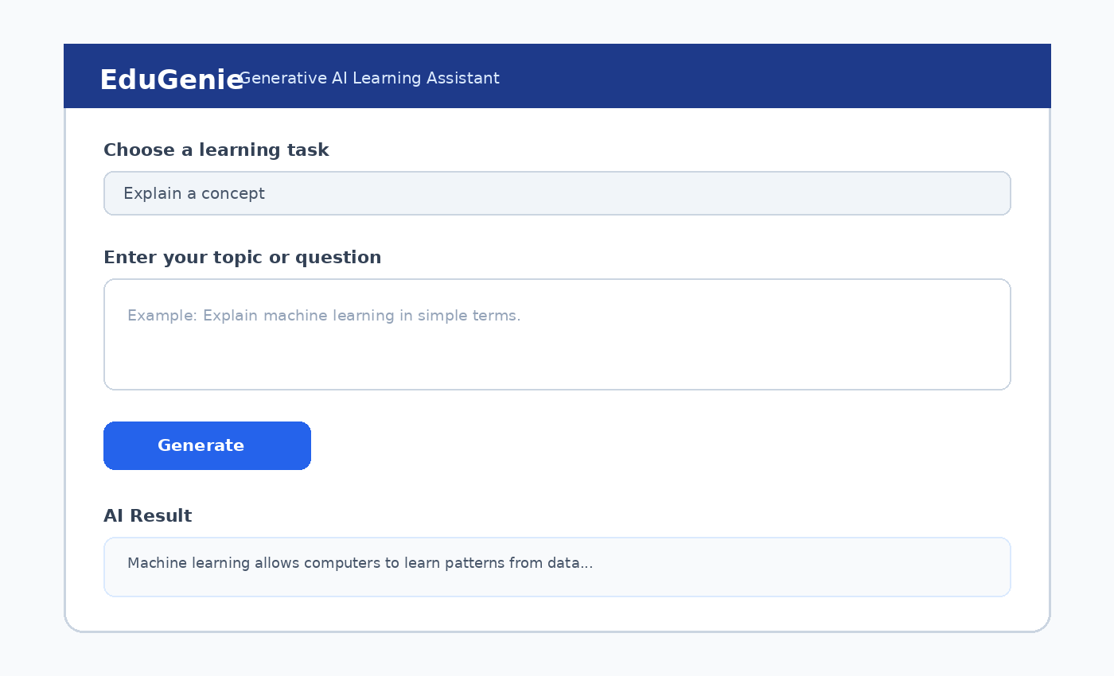

1. Project Overview
EduGenie is a Generative AI Learning Assistant designed to support students with question answering, concept explanation, quiz generation, summarization, and personalized learning recommendations. The project uses HTML/CSS for the frontend, FastAPI for the backend, and the Google Gemini API for AI-generated responses.

2. System Architecture
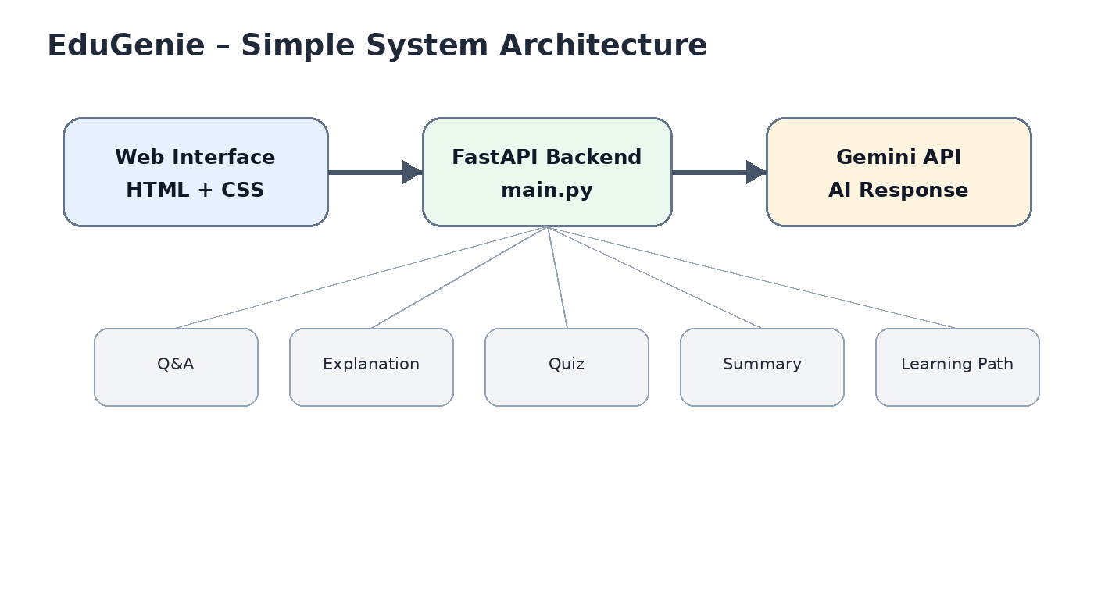

3. Main Features
Q&A: Answer student questions in a clear and educational way.
Explanation: Explain concepts at an accessible level with examples.
Quiz: Generate practice questions for self-assessment.
Summarization: Condense supplied learning material into key points.
Learning Recommendations: Suggest a learning path based on a topic or goal.

4. Project Folder Structure
EduGenie/
├── .env
├── .env.example
├── .gitignore
├── README.md
├── requirements.txt
├── main.py
├── ai_client.py
├── qna.py
├── explanation_module.py
├── quiz_module.py
├── summary_module.py
├── learning_path.py
├── templates/
│ └── index.html
└── static/
└── style.css

5. User Interface

6. Backend Implementation
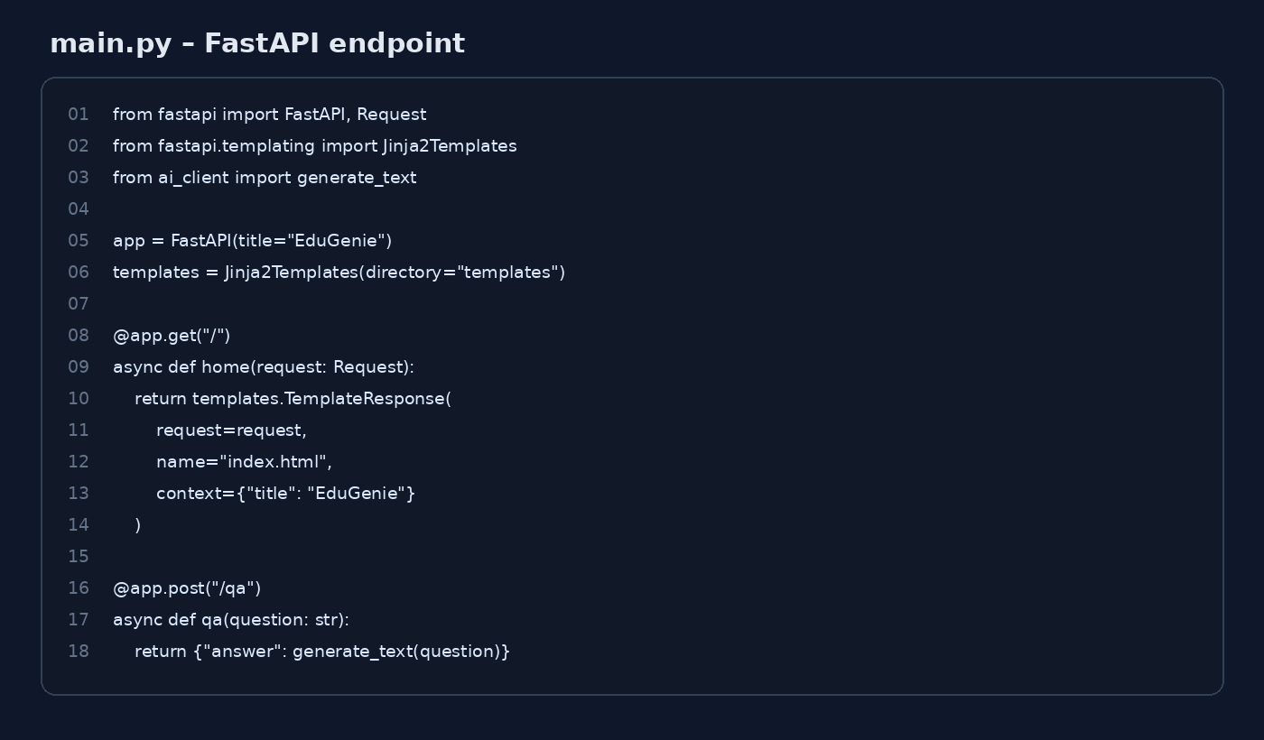

7. AI Configuration
GEMINI_API_KEY=PASTE_YOUR_GEMINI_API_KEY_HERE
GEMINI_MODEL=gemini-2.5-flash
USE_LOCAL_EXPLANATION=false
LOCAL_EXPLANATION_MODEL=MBZUAI/LaMini-Flan-T5-783M

8. Installation and Setup
Open the project in VS Code.
Activate the virtual environment.
Run: python -m pip install -r requirements.txt
Add the Gemini API key to .env.
Run: uvicorn main:app --reload
Open http://127.0.0.1:8000

9. API Endpoints
/qa — Question answering
/explain — Concept explanation
/quiz — Quiz generation
/summarize — Text summarization
/learn/recommendations — Learning recommendations

10. Testing Checklist
☐ Open the homepage.
☐ Test Q&A.
☐ Test Explanation.
☐ Generate a quiz.
☐ Test summarization.
☐ Generate learning recommendations.
☐ Check the terminal for errors.

11. Common Setup Issue
If pip behaves incorrectly, use: python -m pip install -r requirements.txt. If PowerShell blocks activation, use the appropriate activation method for your terminal or temporarily adjust the execution policy for the current session.

12. Conclusion
EduGenie demonstrates a lightweight connection between a web interface, FastAPI backend, and generative AI for educational tasks.

